National College (Autonomous)- Trichy-1
Department of B.Voc. (ICT)
INTERNSHIPS / FIELD PROJECT DETAILS -2021 – 2024

S.No. | Reg No. | Name |  |  | Studying Class |  | Company / Institution Name
1 | ICUS 21001 | SWATHI.M |  |  | III - B.Voc. (ICT) |  | T4TEQ SOFTWARE SOLUTION
2 | ICUS 21003 | PRADEEP.S |  |  | III - B.Voc. (ICT) |  | FANTASY SOLUTION
3 | ICUS 21004 | SESIL ESMI.Y |  |  | III - B.Voc. (ICT) |  | FANTASY SOLUTION
4 | ICUS 21005 | NAVANEETHA KRISHNAN.R |  |  | III - B.Voc. (ICT) |  | FANTASY SOLUTION
5 | ICUS 21006 | SRIRAM.S |  |  | III - B.Voc. (ICT) |  | FANTASY SOLUTION
6 | ICUS 21007 | ARAVIND.M |  |  | III - B.Voc. (ICT) |  | FANTASY SOLUTION
7 | ICUS 21008 | THANGA BALU.C |  |  | III - B.Voc. (ICT) |  | T4TEQ SOFTWARE SOLUTION
8 | ICUS 21009 | SARAVANA SHANMUGAM.M |  |  | III - B.Voc. (ICT) |  | FANTASY SOLUTION
9 | ICUS 21010 | SATHISHKUMAR.S |  |  | III - B.Voc. (ICT) |  | FANTASY SOLUTION
10 | ICUS 21002 | THARANIYAN.K |  |  | III - B.Voc. (ICT) |  | FANTASY SOLUTION

PRADEEP.S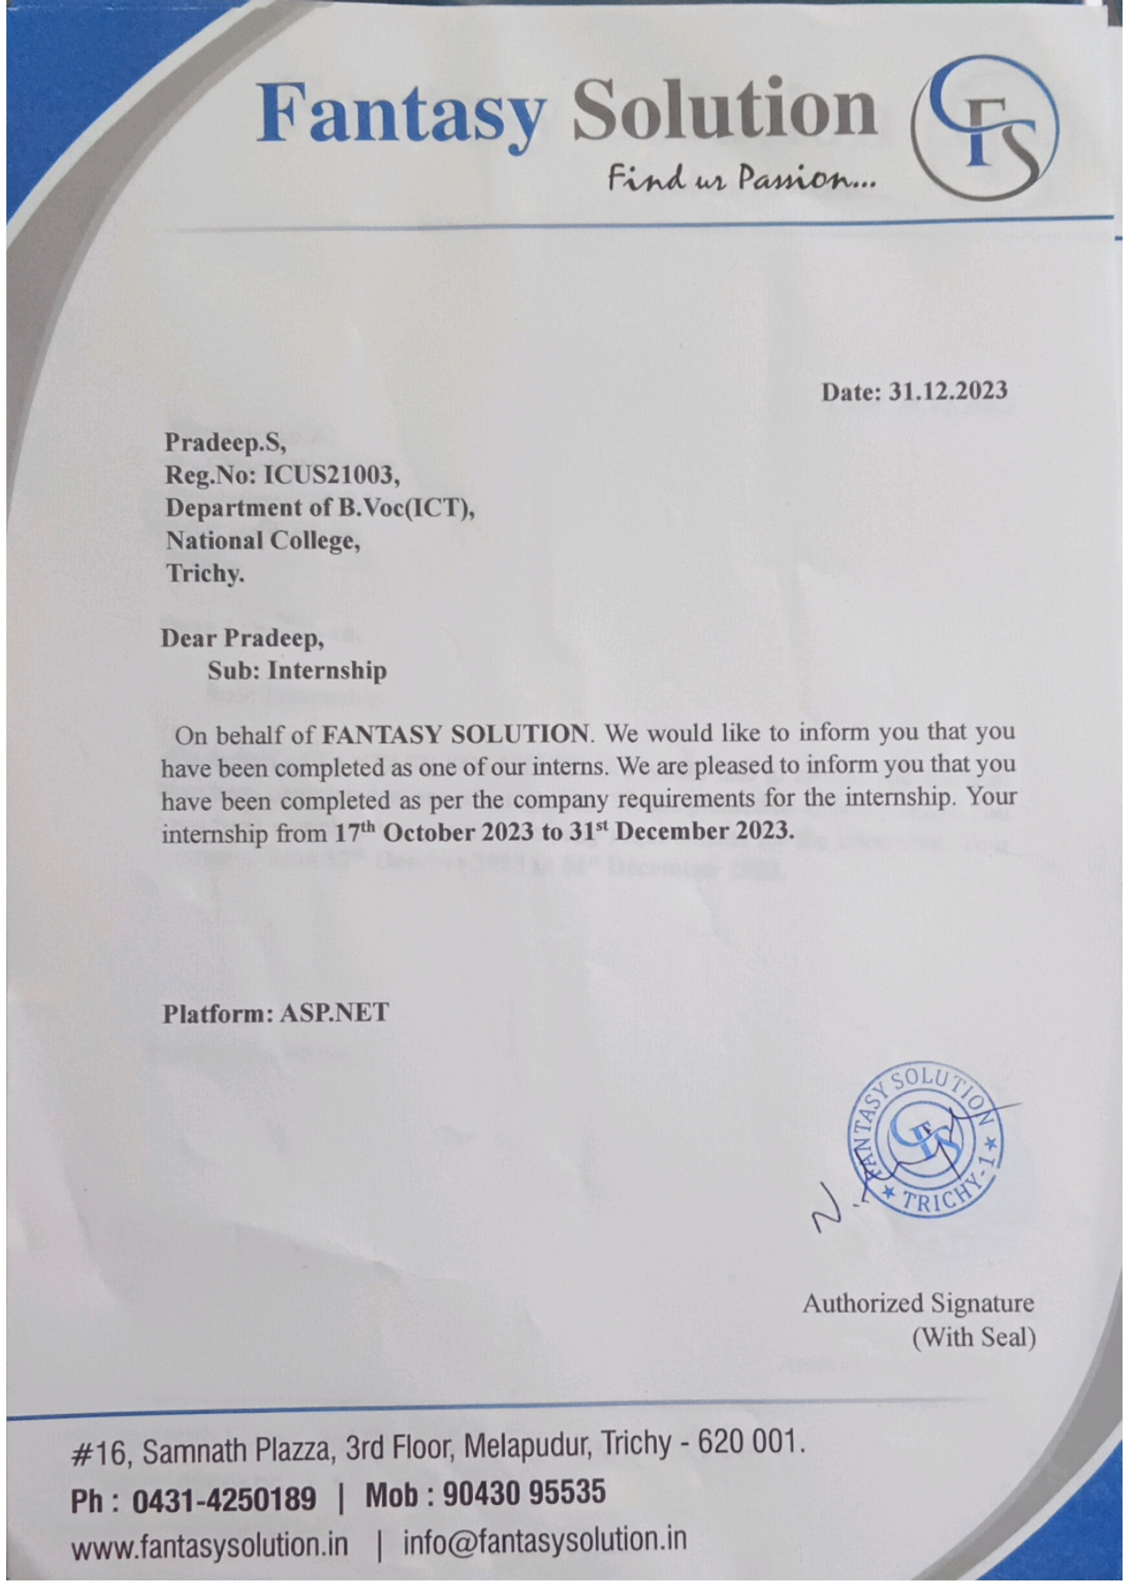

SESIL ESMI.Y
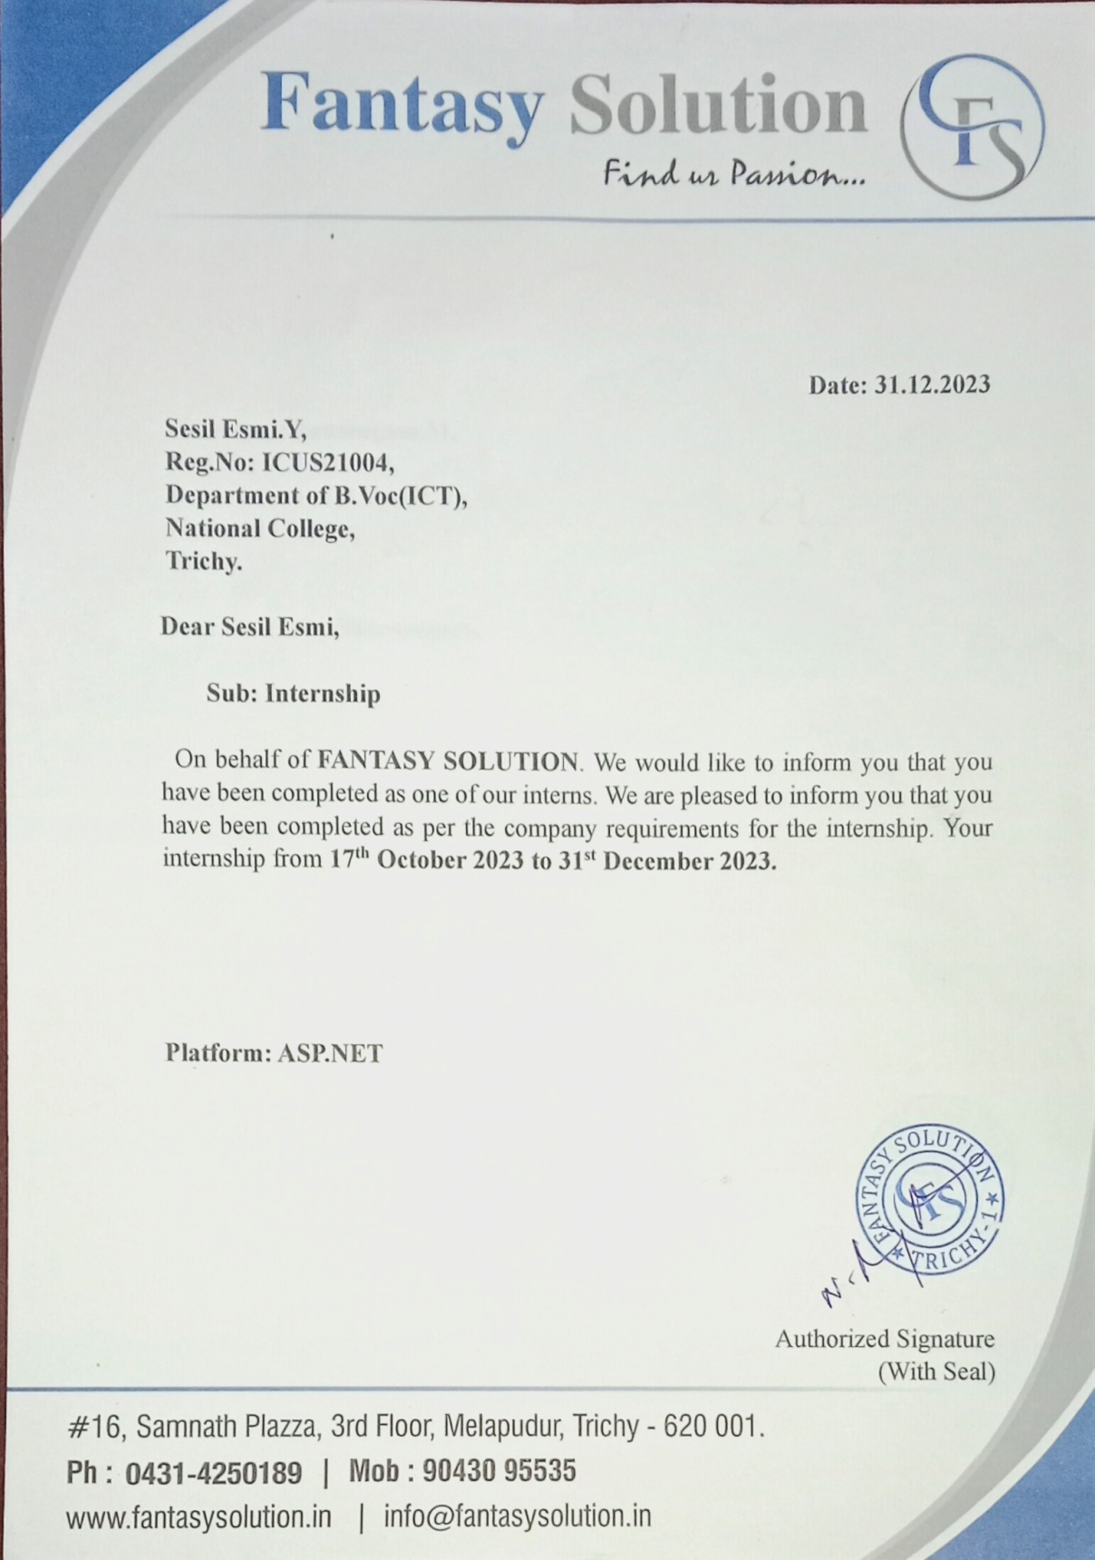

NAVANEETHA KRISHNAN
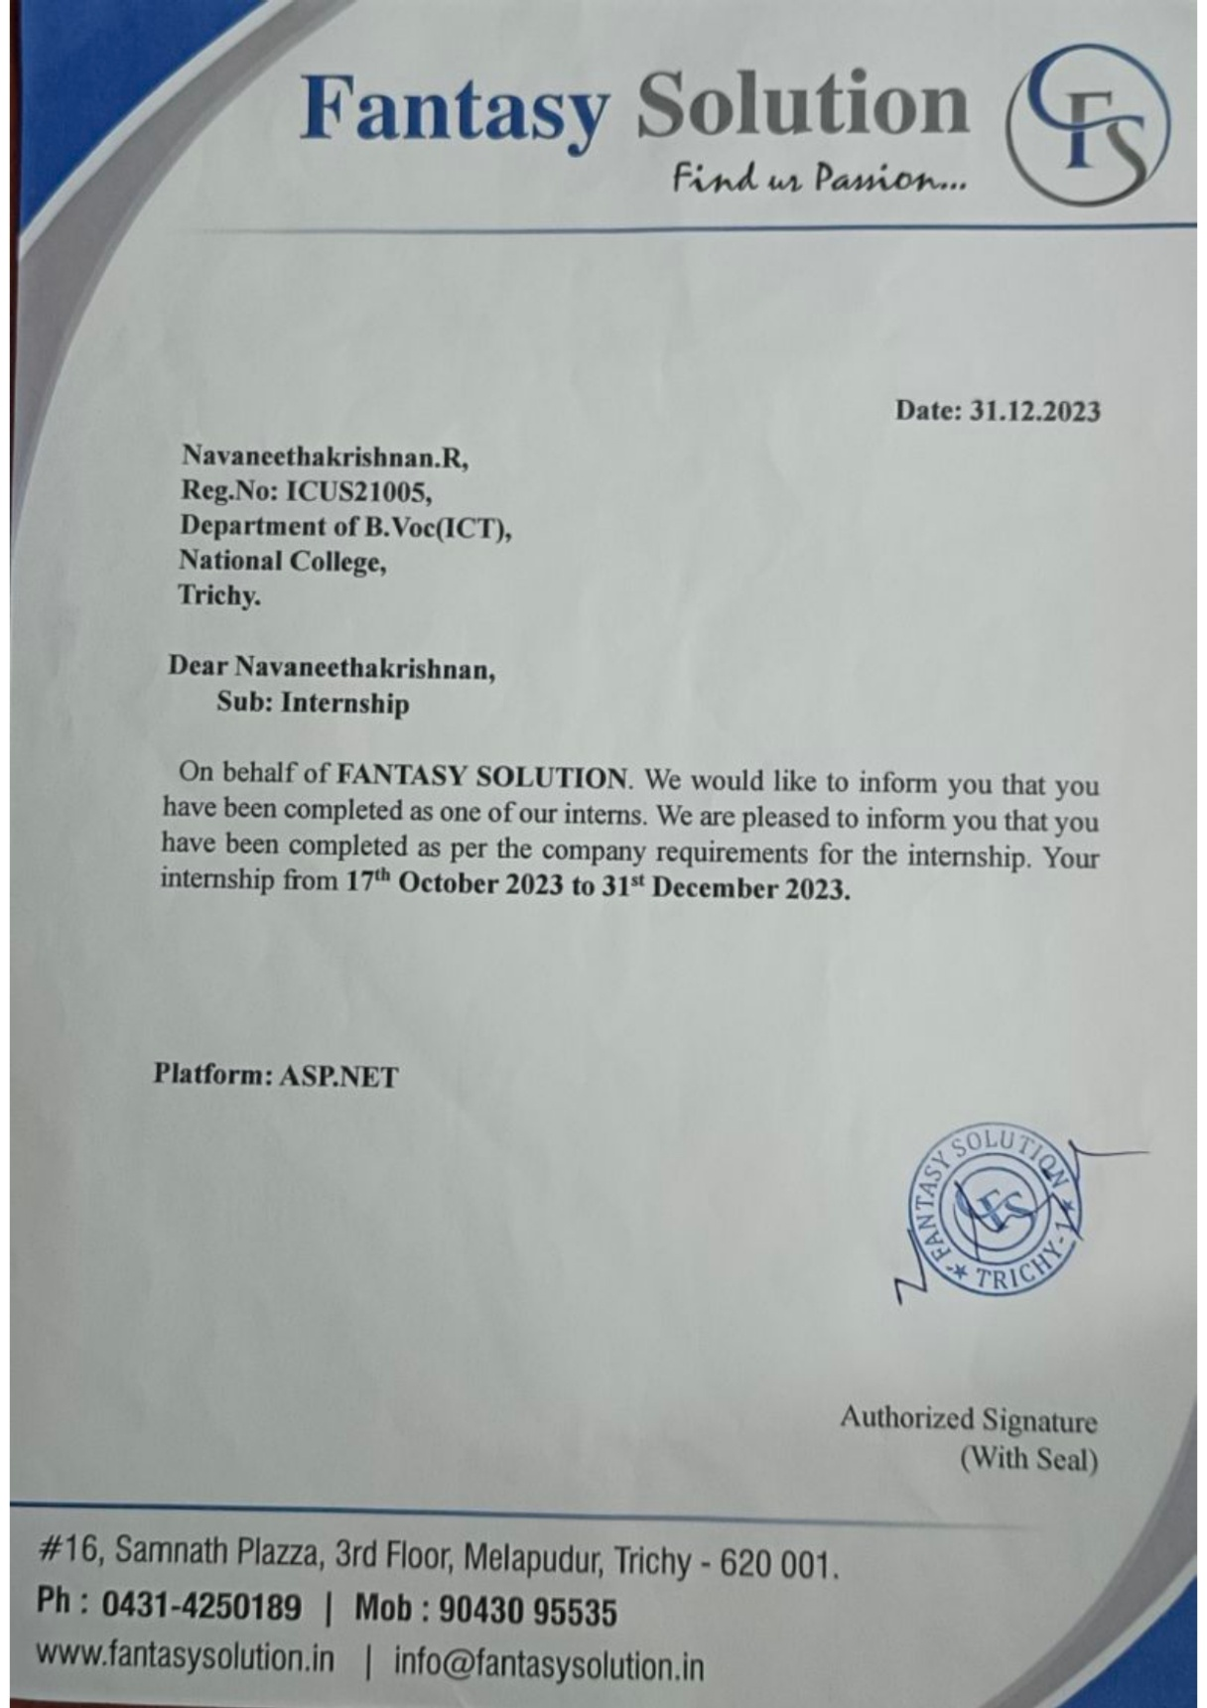

SRIRAM
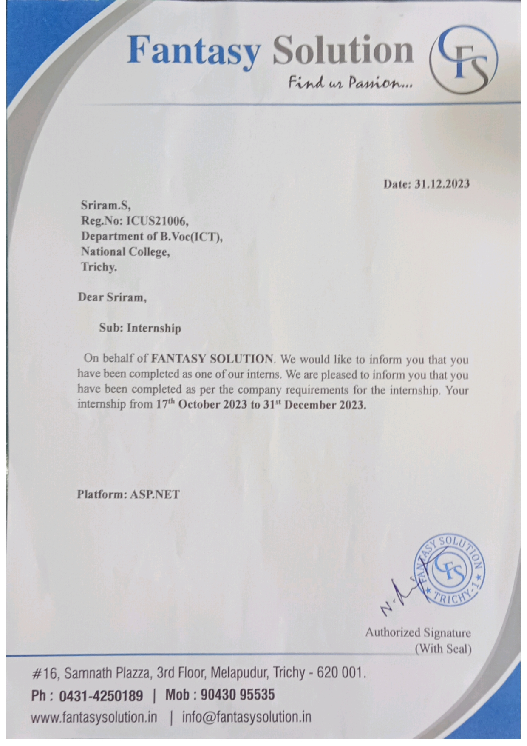
ARAVIND.M

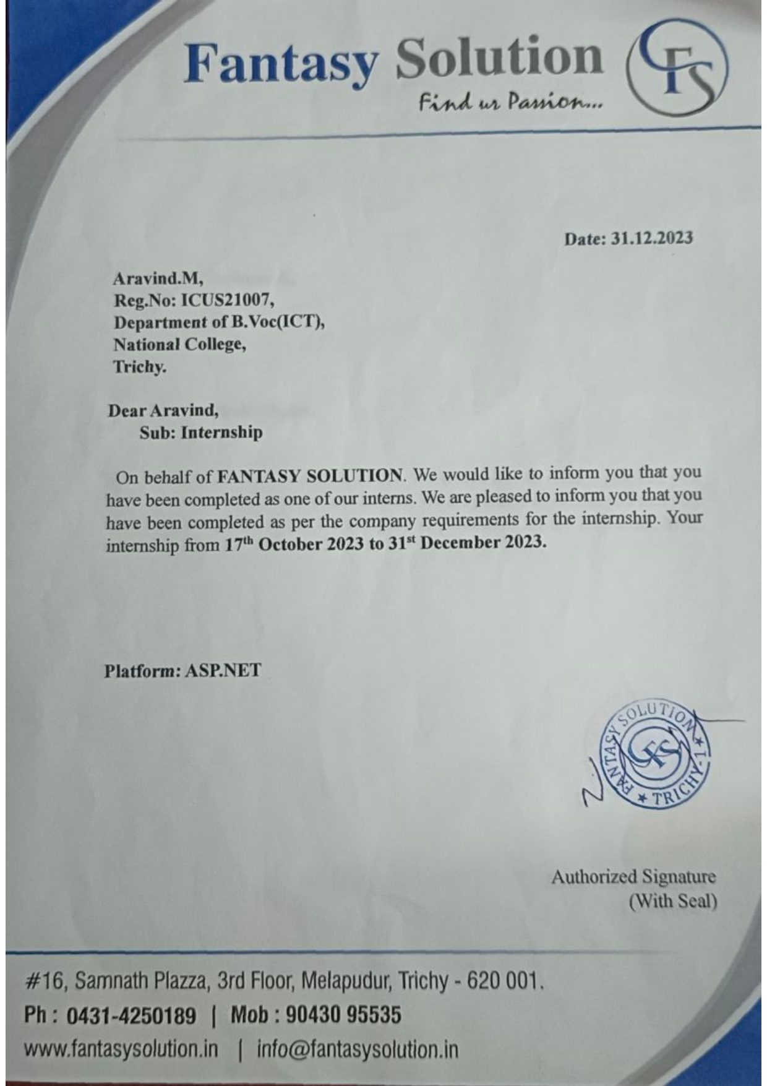

THANGABALU
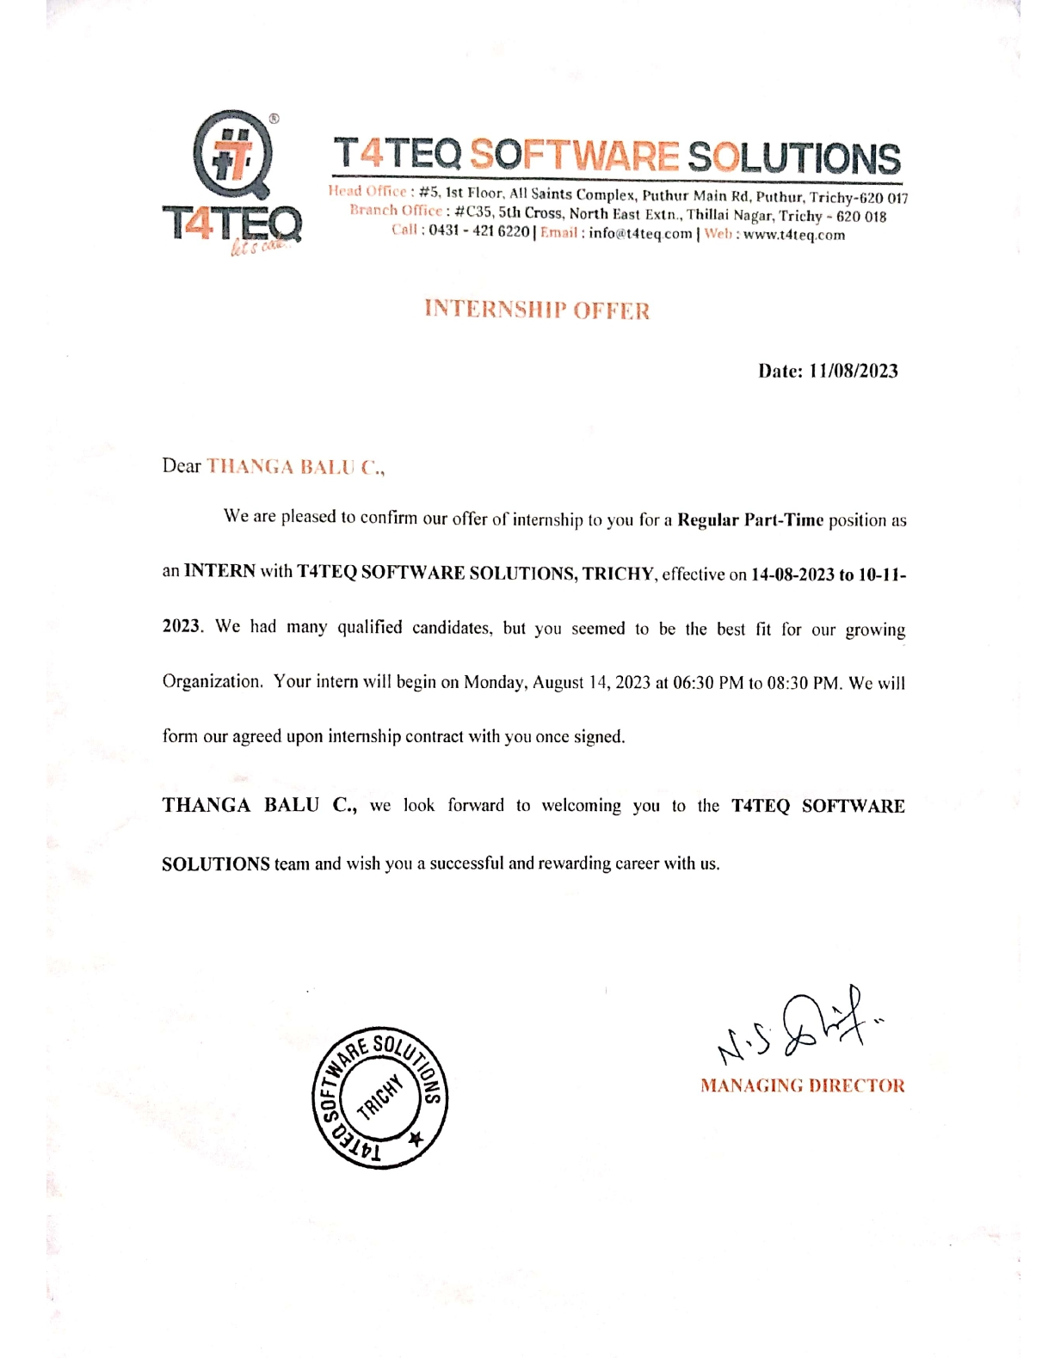

SARAVANA SHANMUGAM.M
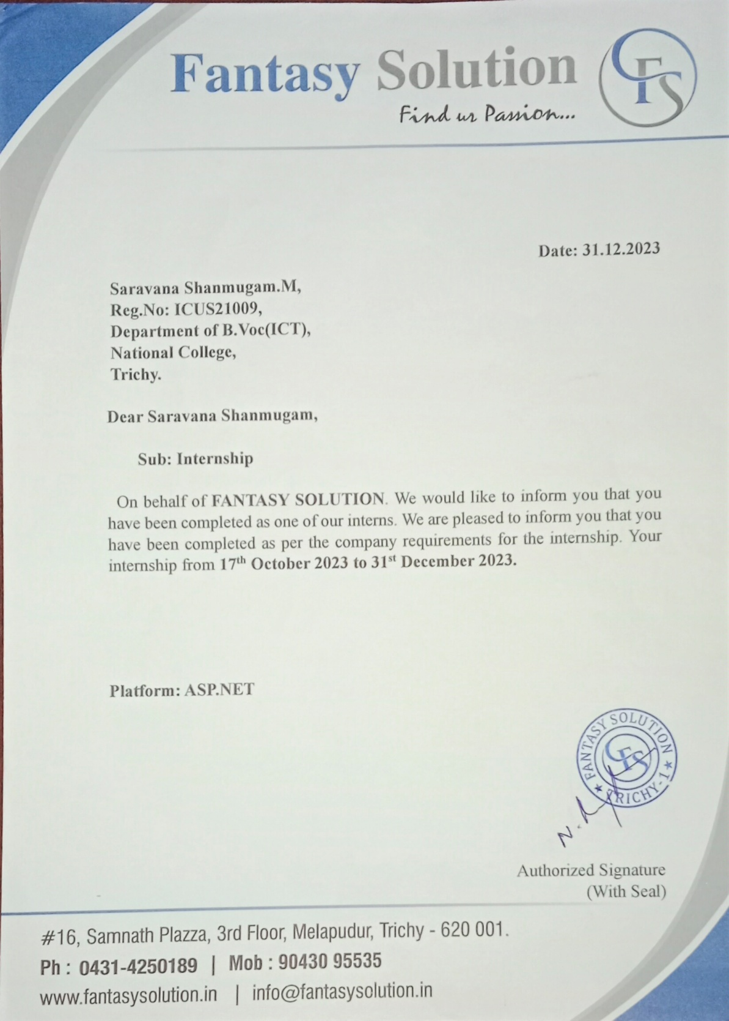

SATHISH KUMAR.S
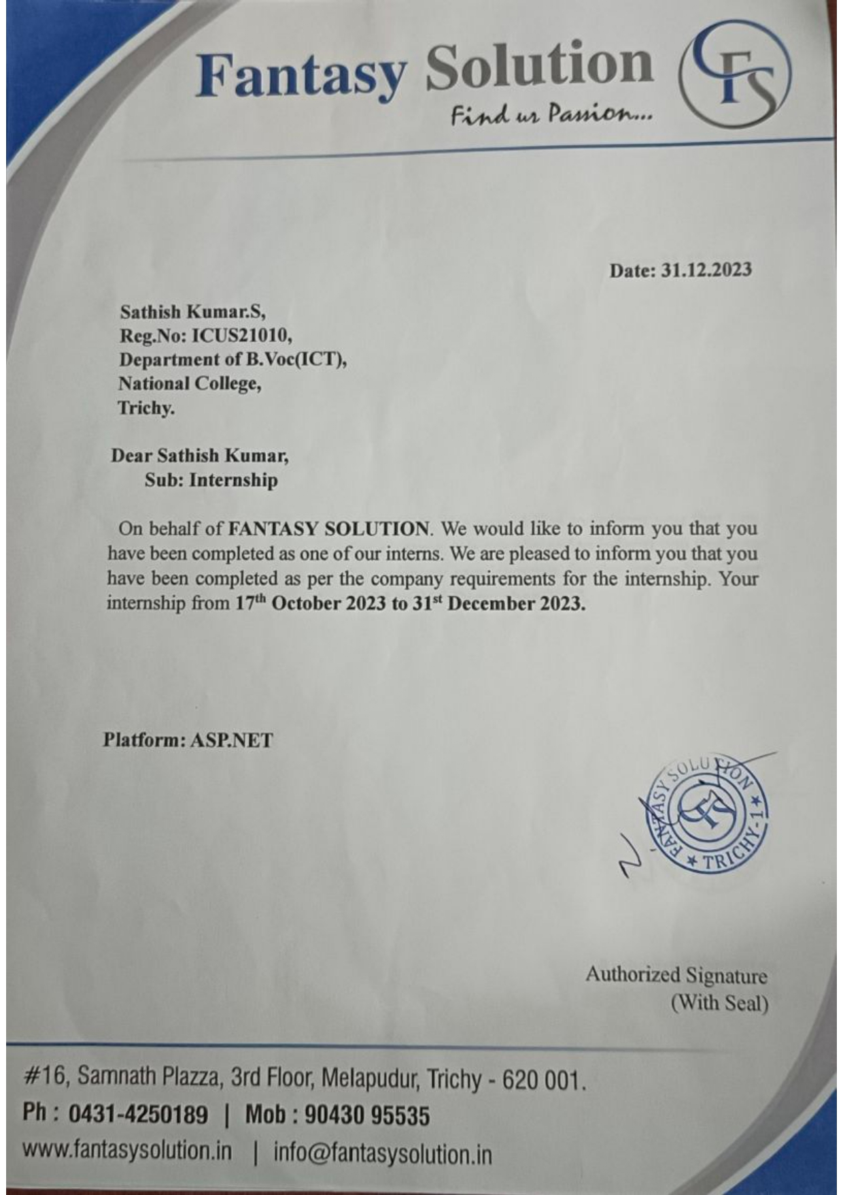

THARANIYAN.K
